Accuracy of Polling for the 2020 Presidential Election

Abstract
Political polling is a defining factor in presidential elections. My goal was to investigate how accurate the political polling for the 2020 United States presidential election was. I did that by examining two primary datasets - one from electoral-vote and the other from 270toWin. I used heat maps to descriptively investigate the difference between what each candidate won and the average prediction per state from the electoral-vote dataset. The 270toWin dataset was analyzed using confidence intervals for the proportion of popular votes each poll predicted compared to the actual election outcomes. I found that across both datasets the polling was more accurate for Biden than for Trump, and that the polls from both datasets reasonably predicted Biden’s outcome but failed to reasonably predict Trump’s.

Background and Significance
As the world becomes more and more connected, new opportunities for data collection on public opinion become easier to do. By utilizing online polling, not only are polls easier to conduct but they are also easier to read. Polling prior to presidential elections is one of the most prominent examples. According to a poll by Pew Research Center (Shearer et. al., 2024) 66% of Americans were following the presidential election in August and September of 2020. Understanding how accurate polls are can help voters make informed decisions based on how the polling shows the election is going. Because of this, I am investigating how accurate the polling of the 2020 presidential election was.

Data collection
During my first iteration, I was looking for a dataset that showed polling by state. I eventually found a dataset of state level polls from electoral-vote.com, a site that tracks political polls for federal elections by aggregating polls from other companies. The electoral-vote dataset had a large number of state polls but did not have sample sizes.
After realizing that without sample sizes, I could not do the analysis that I wanted to because creating confidence intervals requires sample sizes, I began looking for a new dataset. I wanted to get state level polls that included sample size, but I could not find anything suitable. So, I decided to look for a set of national polls that had sample sizes. I eventually decided to use a dataset from 270toWin, a nonpartisan site that aggregates polls and provides interactive mapping tools. It launched shortly before the 2004 presidential election. The dataset had sample sizes and 450 polls from as far back as December 2019 with a median sample size of 1,200, and an average sample size of 3,456. It also grouped all third parties into one category.

Analytic Methods
I loaded the electoral-vote dataset into RStudio and conducted some exploratory data analysis. First, I grouped the polls by state and averaged the vote proportion for each candidate within each state. To see if there was a significant change in the accuracy as polls got closer to the election, I calculated one average based on all polls within the state and one average based only on polls within two months before the election. Second, I compared the average from polls within two months prior to the actual vote proportion won by the candidate in that state. This difference was plotted on a heat map to observe which states underpredicted for a given candidate and which states overpredicted. Finally, I considered the absolute value of this difference and averaged it across all states to calculate the magnitude of the difference between vote proportion predicted by state-by-state polling and the national outcome.
I loaded the 270toWin dataset into RStudio and created a new variable that represented the difference between the proportion of the popular vote that each candidate won and the proportion each poll predicted. Then I created 95% confidence intervals using each poll’s predictions and comparing it to the actual amount each candidate won.

Results

Exploratory Data Analysis
The dataset from electoral-vote showed that the average of the absolute value of the difference between the percent of a given state they were predicted to get and what each candidate won was 1.73% for Biden and 3.91% for Trump, when looking at polls conducted over the course of the year. When looking only at polls conducted in the 2 months before the election, the difference narrowed to 1.45% for Biden and 3.19% for Trump.
When considering the direction of differences, the state with the least accurate polling in the 2 months before the election for both candidates was West Virgina, where the polls overestimated Biden by 6.56% and underestimated Trump by 9.62%. The electoral-vote dataset only had 2 polls in West Virgina in that time window, which was likely a factor in the low accuracy. However, there were many other states with a similar number of polls and a more accurate result. The state with the most accurate polling for Trump in the 2 months before the election was North Dakota where the polling average was only off by 0.12%. However, there was only one poll of North Dakota in that time window. The state with the most accurate polling for Biden in the two months before the election was North Carolina where the average was 0.002% off. The electoral-vote dataset included 20 polls for North Carolina in that time window, the third highest in the dataset. Figure 1 shows the state-by-state differences between the actual vote share and the polling average. In a state with a higher percentage the given candidate outperformed the polls.

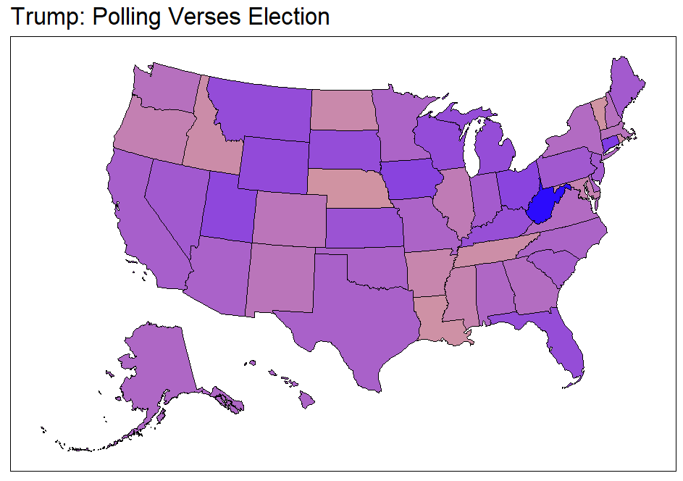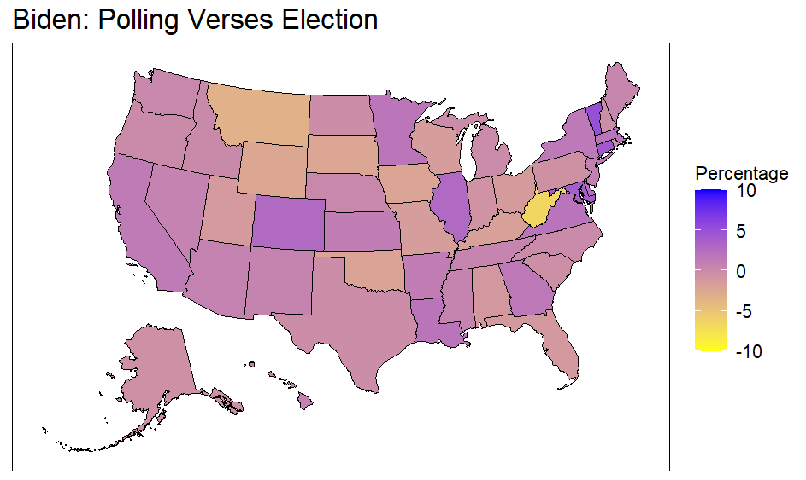
Figure 1: Difference between the average of the polls and what each candidate won

Inferential Data Analysis
Of the 452 polls in the 270toWin dataset, 266 (58.85%) captured the true proportion of the popular vote that Biden won in a 95% confidence interval. Of the 452 polls, 87 (19.25%) captured the true proportion of the popular vote that Trump won in their confidence intervals. Only 61 (13.5%) of the confidence intervals contained both candidates’ proportion of the vote.
If the polls had perfectly representative samples and no time difference between the poll and the election, I would expect that 95% of the polls would capture the true proportion of the popular vote. This indicates that the difference is caused by the time elapsed between the polling and the election, and the fact that the samples may not be perfectly representative.
The two graphs in Figure 2 show 95% confidence intervals for the last five polls in the 270toWin dataset before the election. The red line represents the proportion of the popular vote that each candidate won. The plots showing the 5 earliest polls are in the appendix. Across all polls, I observed that they typically captured Biden's true proportion and missed Trump's.

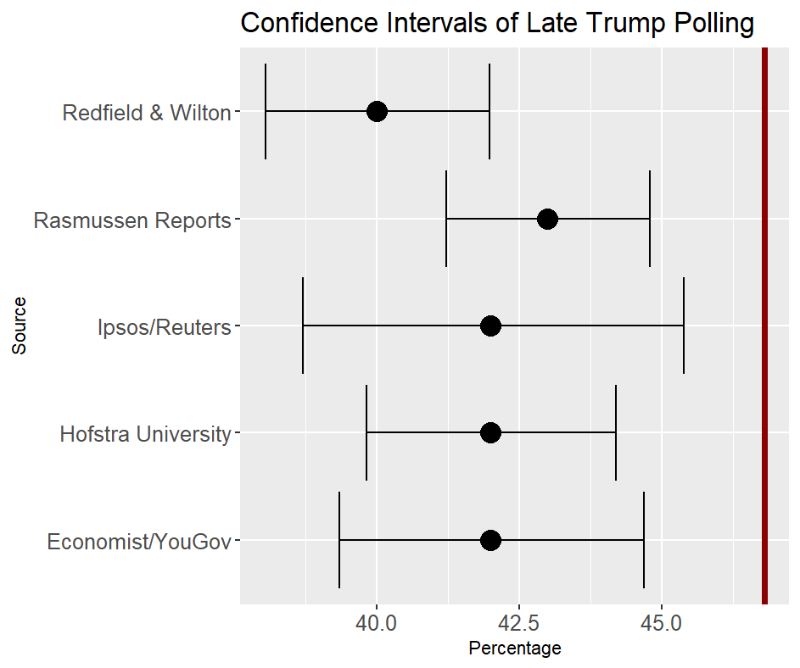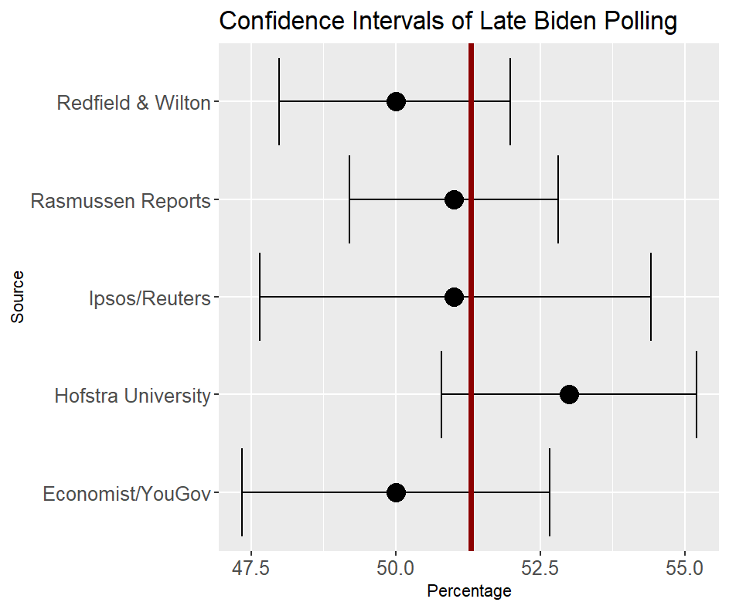
Figure 2: Confidence Intervals of the last 5 polls before election

Conclusion
Across both datasets the polling was more accurate for Biden than for Trump. In the electoral vote dataset, the average difference between the average polling for a state and what each candidate won in that state was 1.73% for Biden and 3.91% for Trump. Also, in the 270toWin dataset 58.85% of the polls captured Biden’s true proportion while only 19.25% captured Trump’s.
One possible limitation of the study is a rounding error. I created a new variable by multiplying the proportion the polls thought each candidate would win by the sample size. This introduced a slight rounding error in the confidence intervals. However, given the large sample sizes I do not believe it is a significant problem. Another limitation is that the data from 270toWin is predicting the popular vote not the winner of the election.
In the future I would like to work on the 2024 presidential election because it is more recent and thus more relevant. I would also like to find a dataset that includes state-level information and sample sizes, and I would like to investigate if it is common for polling accuracy to diverge this much between candidates in the same race.
It is encouraging that the polls predicted the candidate that won the popular vote at a better rate but unusual that there was such a large gap in the accuracy of the polls for each candidate. Overall, the polls from both datasets predicted Biden’s outcomes with a reasonable amount of accuracy, but in my estimation failed to reasonably predict Trump’s outcome.

References
Downloadable Data. (n.d.). Retrieved from electoral-vote: https://www.electoral-vote.com/evp2020/Info/data.html
Kaplan, D., & Beckman, M. (2021, 1 19). Data Computing (2nd edition). Retrieved from dtkaplan.github.io: https://dtkaplan.github.io/DataComputingEbook/index.html#table-of-contents
National 2020 Presidential Election Polls. (n.d.). Retrieved from 270toWin: https://www.270towin.com/2020-polls-biden-trump/national/
Shearer, E., Lipka, M., Naseer, S., Tomasik, E., & Jurkowitz, M. (2024, October 10). How closely are Americans following election news and what are they seeing? Retrieved from pewresearch: https://www.pewresearch.org/journalism/2024/10/10/how-closely-are-americans-following-election-news-and-what-are-they-seeing/

Appendix
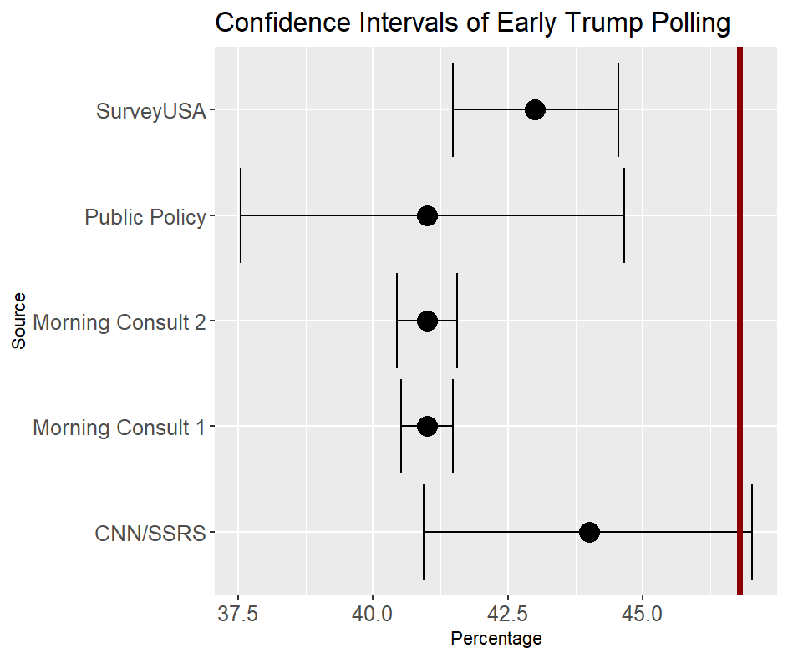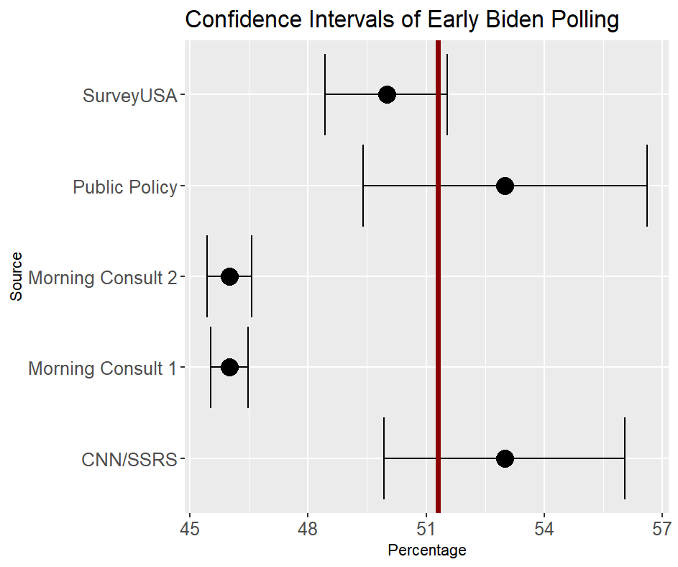
95% Confidence intervals of earliest polls in 270toWin dataset

